**Session 4**

**Stack and queue**

* Stack concept
* Stack application
* Queue concept
* Circular queue
* Priority queue
* Infix, Prefix, and postfix notation

Stack:

* Imagine a pile of plates where one plate is placed on top of another
* When you want to remove a plate, you remove the topmost plate first
* 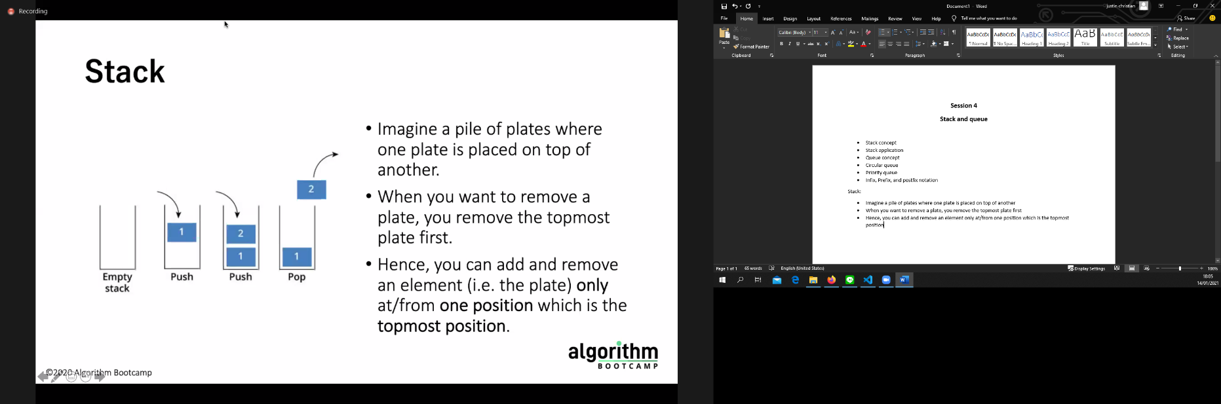Hence, you can add and remove an element only at/from one position which is the topmost position
* Stack is a linear data structure which can be implemented using an array or a linked list
* Elements are added and removed only from the topmost elemenet called the top
* Data stored in a last in first out (LIFO)

Stack using Array

* Stack has TOP(topmost element) and Max(maximum number of elements)
* If TOP == NULL, stack is empty.
* 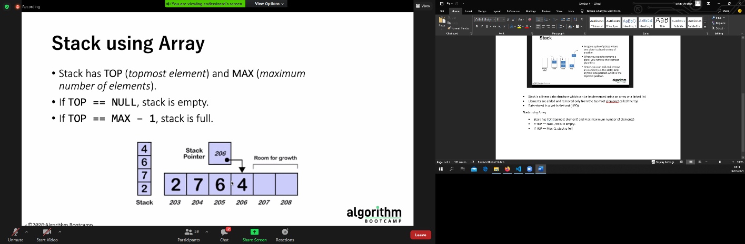If TOP == Max -1, stack is full

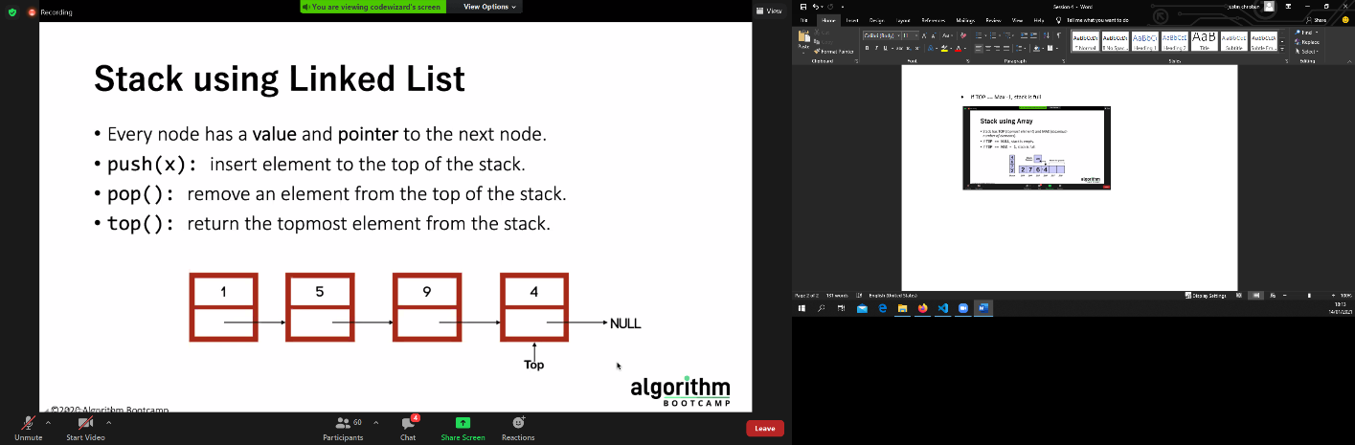

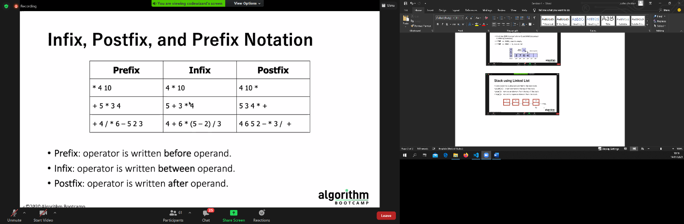

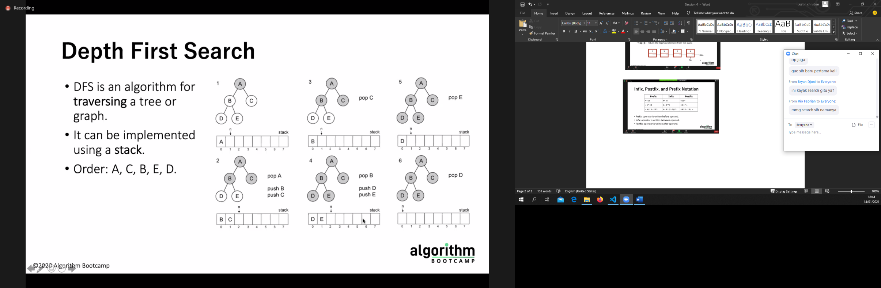

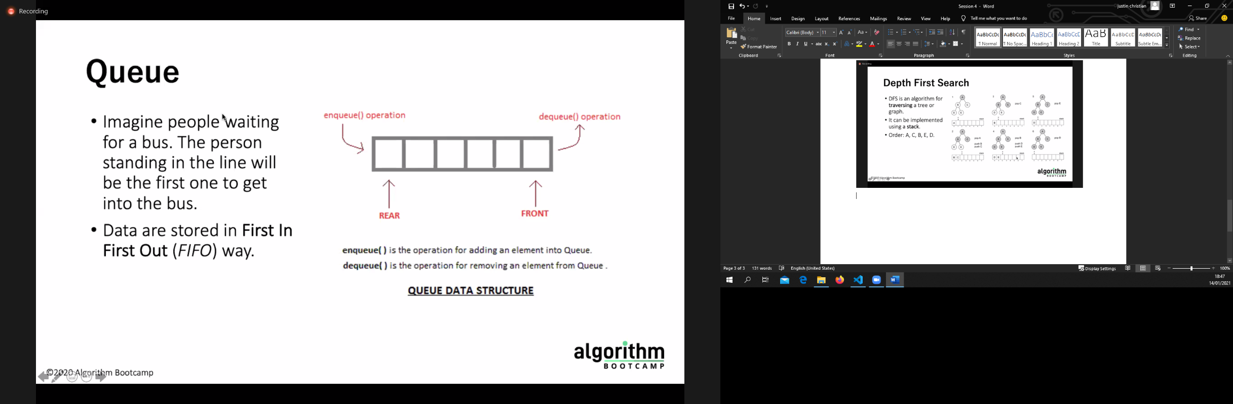

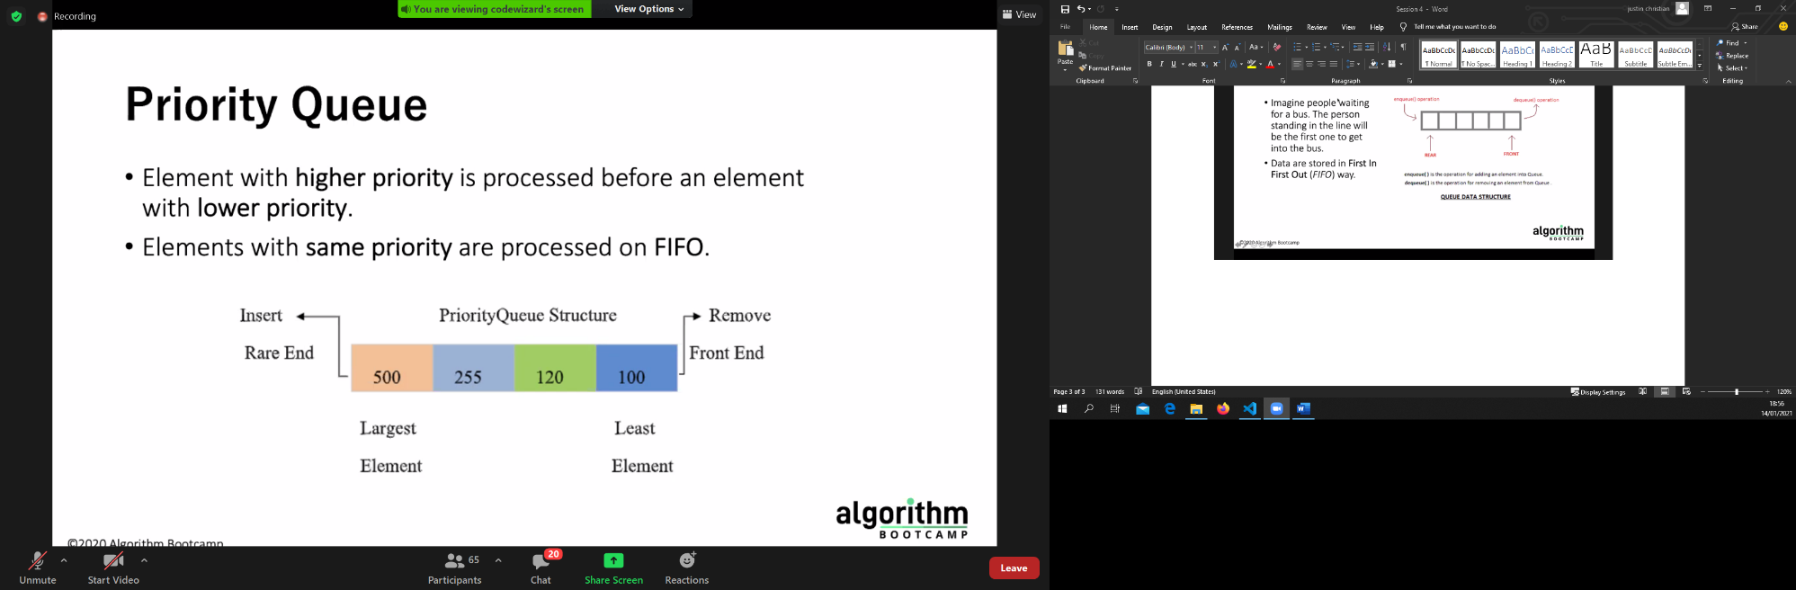

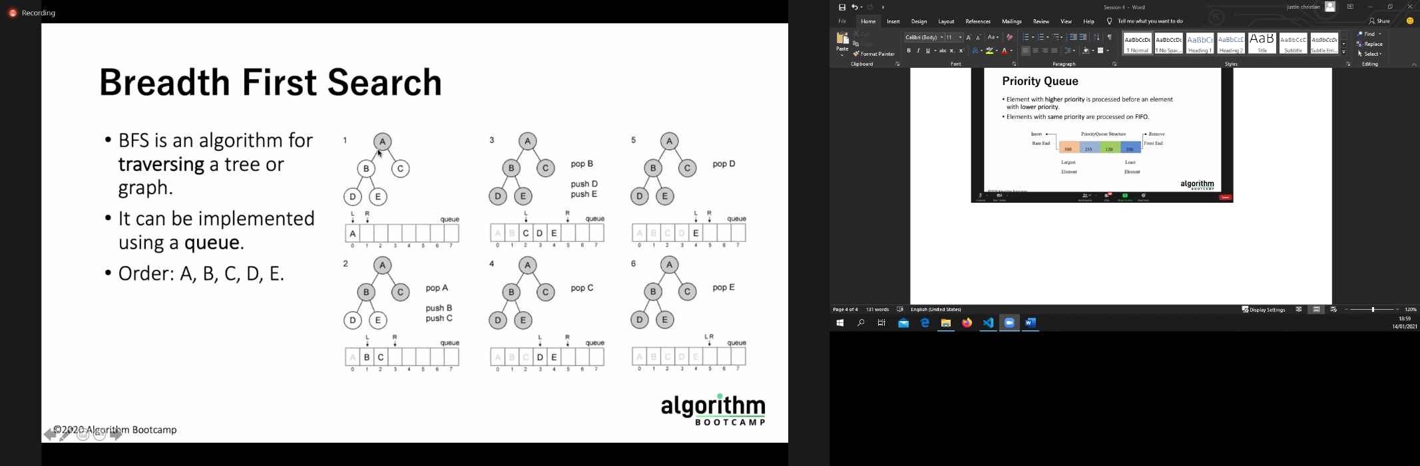

bfs == bisa cari shortest path di unweighted graph

dfs == ga bisa

dfs itu lebih bagus dipakai kalau kita mencari "apakah ada suatu jalan atau tidak"